DRIVING AND PARKING DIRECTIONS TO THE OCRUG HACKATHON

UCI THE PAUL MERAGE SCHOOL OF BUSINESS – UCI SOCIAL SCIENCE PARKING STRUCTURE

For a map and driving directions to UC Irvine’s Paul Merage School of Business, check out https://bit.ly/2TAkDCV or used GRS locator: **4289 Campus Dr., Irvine**. This address will take you to the *Jack in the Box restaurant* that is across the UCI parking garage (Social Science Parking Structure). The Social Science Parking Structure is at the intersection of Campus Drive and Stanford Court.

PARKING STRUCTURE

At the traffic light where Campus Drive and Stanford Court cross, follow the green arrow on the map below and turn into the Social Sciences Parking Structure.

MERAGE SCHOOL OF BUSINESS I – LOBBY

The Merage School of Business **(SB1)** and Merage School of Business II **(SB2)** are located next to each other, across the parking structure. Follow the yellow line marked on the map below.

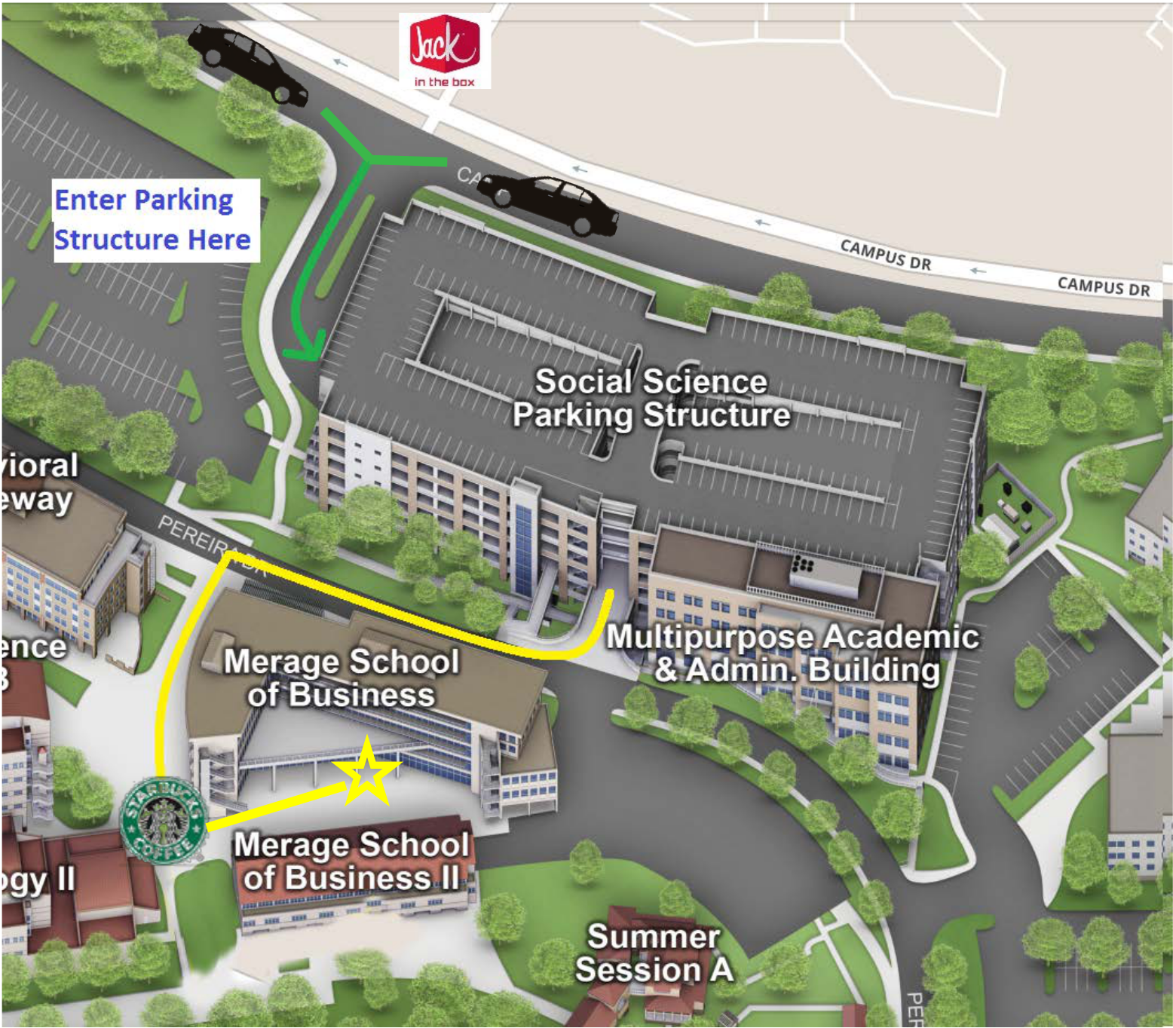

BUILDING DIRECTIONS

As you exit the parking structure, you should be facing the Merage School **(SB1)** with the parking structure behind you (picture 1). Exit the parking structure and cross the street between the parking structure and the building. SB1 is a 5-story glass and cement building with orange walls. Begin walking towards the building and along the asphalt pathway until you reach the brick paved intersection where you will turn left (picture 2). Continue to walk along SB1 and bear left until you see a Starbucks on your left. Walk through the corridor next to Starbucks (picture 3). Once you exit the corridor SB2 will be the building on your right.

**View when exiting parking structure**

